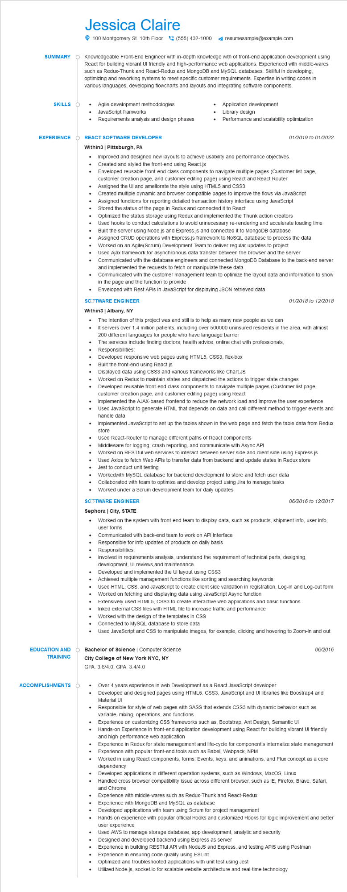
SUMMARY
Jessica Claire
100 Montgomery St. 10th Floor(555) 432-1000
resumesample@example.com
Knowledgeable Front-End Engineer with in-depth knowledge with of front-end application development using React for building vibrant UI friendly and high-performance web applications. Experienced with middle-wares such as Redux-Thunk and React-Redux and MongoDB and MySQL databases. Skillful in developing, optimizing and reworking systems to meet specific customer requirements. Expertise in writing codes in various languages, developing flowcharts and layouts and integrating software components.
SKILLS
•
Agile development methodologies
•
JavaScript framworks
Requirements analysis and design phases
Application development Library design
Performance and scalability optimization
EXPERIENCE
EDUCATION AND
TRAINING
REACT SOFTWARE DEVELOPER
Within3 | Pittsburgh, PA
• Improved and designed new layouts to achieve usability and performance objectives. Created and styled the front-end using React.js
•
01/2019 to 01/2022
Enveloped reusable front-end class components to navigate multiple pages (Customer list page, customer creation page, and customer editing page) using React and React Router Assigned the UI and ameliorate the style using HTML5 and CSS3
·
•
•
•
•
Created multiple dynamic and browser compatible pages to improve the flows via JavaScript
Assigned functions for reporting detailed transaction history interface using JavaScript
Stored the status of the page in Redux and connected it to React
Optimized the status storage using Redux and implemented the Thunk action creators
Used hooks to conduct calculations to avoid unnecessary re-rendering and accelerate loading time
Built the server using Node.js and Express.js and connected it to MongoDB database
Assigned CRUD operations with Express.js framework to NoSQL database to process the data
Worked on an Agile(Scrum) Development Team to deliver regular updates to project
Used Ajax framework for asynchronous data transfer between the browser and the server
Communicated with the database engineers and connected MongoDB Database to the back-end server and implemented the requests to fetch or manipulate these data
Communicated with the customer management team to optimize the layout data and information to show in the page and the function to provide
Enveloped with Rest APIs in JavaScript for displaying JSON retrieved data
SCOTWARE ENGINEER
Within3 | Albany, NY
•
The intention of this project was and still is to help as many new people as we can
01/2018 to 12/2018
It servers over 1.4 million patients, including over 500000 uninsured residents in the area, with almost
200 different languages for people who have language barrier
The services include finding doctors, health advice, online chat with professionals,
Responsibilities:
Developed responsive web pages using HTML5, CSS3, flex-box
•
•
•
Built the front-end using React.js
Displayed data using CSS3 and various frameworks like Chart.JS
•
•
Worked on Redux to maintain states and dispatched the actions to trigger state changes
Developed reusable front-end class components to navigate multiple pages (Customer list page, customer creation page, and customer editing page) using React
Implemented the AJAX-based frontend to reduce the network load and improve the user experience Used JavaScript to generate HTML that depends on data and call different method to trigger events and handle data
Implemented JavaScript to set up the tables shown in the web page and fetch the table data from Redux store
•
Used React-Router to manage different paths of React components
•
Middleware for logging, crash reporting, and communicate with Async API
•
Worked on RESTful web services to interact between server side and client side using Express.js
Used Axios to fetch Web APIs to transfer data from backend and update states in Redux store Jest to conduct unit testing
Workedwith MySQL database for backend development to store and fetch user data Collaborated with team to optimize and develop project using Jira to manage tasks
• Worked under a Scrum development team for daily updates
SCOTWARE ENGINEER
06/2016 to 12/2017
Sephora | City, STATE
• Worked on the system with front-end team to display data, such as products, shipment info, user info, user forms.
•
Communicated with back-end team to work on API interface
Responsible for info updates of products on daily basis
•
Responsibilities:
Involved in requirements analysis, understand the requirement of technical parts, designing,
development, Ul reviews, and maintenance
Developed and implemented the UI layout using CSS3
•
Achieved multiple management functions like sorting and searching keywords
Used HTML, CSS, and JavaScript to create client side validation in registration, Log-in and Log-out form
Worked on fetching and displaying data using JavaScript Async function
Extensively used HTML5, CSS3 to create interactive web applications and basic functions
Inked external CSS files with HTML file to increase traffic and performance
•
Worked with the design of the templates in CSS
Connected to MySQL database to store data
•
Used JavaScript and CSS to manipulate images, for example, clicking and hovering to Zoom-In and out
Bachelor of Science | Computer Science
City College of New York NYC, NY
GPA: 3.6/4.0, GPA: 3.4/4.0
06/2016
ACCOMPLISHMENTS
•
Over 4 years experience in web Development as a React JavaScript developer
Developed and designed pages using HTML5, CSS3, JavaScript and UI libraries like Boostrap4 and Material Ul
Responsible for style of web pages with SASS that extends CSS3 with dynamic behavior such as variable, mixing, operations, and functions
Experience on customizing CSS frameworks such as, Bootstrap, Ant Design, Semantic Ul
Hands-on Experience in front-end application development using React for building vibrant UI friendly and high-performance web application
•
Experience in Redux for state management and life-cycle for component's internalize state management Experience with popular front-end tools such as Babel, Webpack, NPM
Worked in using React components, forms, Events, keys, and animations, and Flux concept as a core dependency
Developed applications in different operation systems, such as Windows, MacOS, Linux
Handled cross browser compatibility issue across different browser, such as IE, Firefox, Brave, Safari, and Chrome
•
Experience with middle-wares such as Redux-Thunk and React-Redux
•
Experience with MongoDB and MySQL as database
Developed applications with team using Scrum for project management
•
Hands on experience with popular official Hooks and customized Hooks for logic improvement and better user experience
......
Used AWS to manage storage database, app development, analytic and security
Designed and developed backend using Express as server
Experience in building RESTful API with NodeJS and Express, and testing APIS using Postman Experience in ensuring code quality using ESLint
Optimized and troubleshooted applications with unit test using Jest
Utilized Node.js, socket.io for scalable website architecture and real-time technology

